Midweek Wayfarers Arnside Holiday 2025

The holiday in Arnside commences on Saturday 4th October 2025. It is for a week.

You need your own transport to get there - by car or easily by train. Lift sharing can be arranged once it is known who is going and from where.

The price is £445 per person fully inclusive and includes, bed, breakfast, evening meal and a packed lunch. There is no single supplement.

The food is excellent, wholesome, and everything you need after a day's activities.
The breakfast is full English, or less if you want, and sets you up for the day.

See sample menu below.

The last 3 years have been extremely successful. Please speak with some of those who went to hear all about it.
We stay at:

Parkside Guest House
59 Redhills Road, Arnside, Via-Carnforth, LA5 0AU
Parkside is run by the Greycourt Fellowship www.greycourtholidays.co.uk

Please click RSVP/Attend/Submit on Meetup to indicate if you wish to be put on the list of potential participants for 2025 to give us a guide as to how many people are interested.

For further details, please contact Verner Wheelock at verner.wheelock@vwa.co.uk
A firm Booking can be secured by a deposit of £20 (non-returnable).
This offer is open to members of The Midweek Wayfarers. To join costs £10 per year.

Optional Activities*

- Short walks, medium walks and longer walks around Arnside Knot, Silverdale, Fairy Steps, Ulverston Tower and Grange Hospice.
- Visits to Morecombe and Heysham
- Visit to Lancaster Castle and Jail
- Visit to Levens Hall
- Mini Golf
- Access to Lakes for serious climb / walk
- Arnside’s popular cafes and pubs for after walk or evening enjoyment
- Evening activities for those that want to participate like Cards, Dominoes or just relax in the lounge for coffees / drinks and a chat or watch TV.

*The optional activities listed above are for the participants to organise amongst themselves. They are not organised or led by the Midweek Wayfarers. Many of the past participants have knowledge of the walks / location and may choose to lead them but it is at their discretion.

Pictures from the Past Holidays

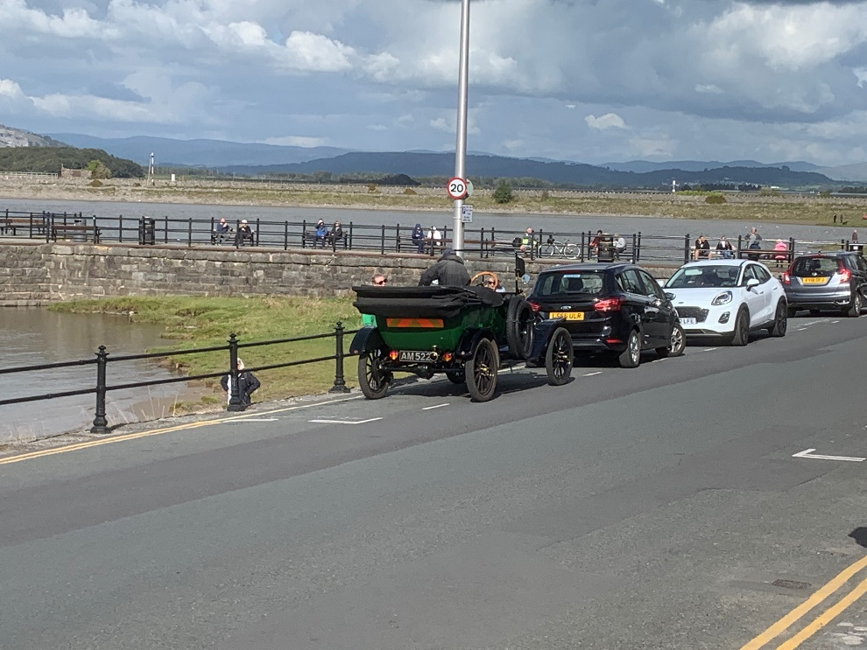
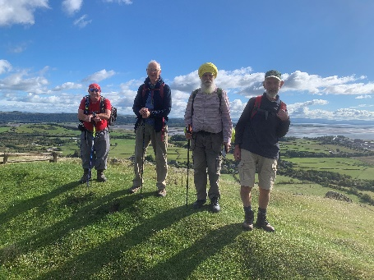
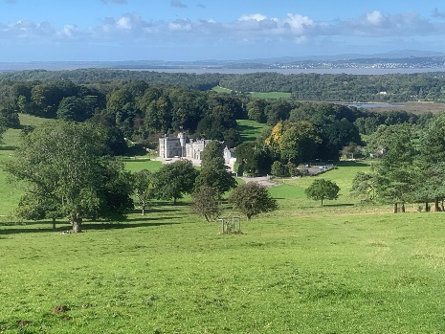
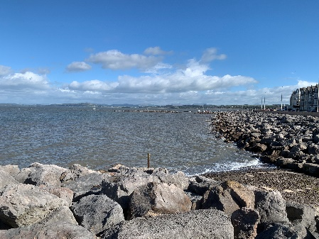
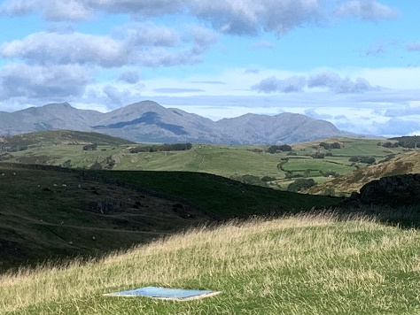
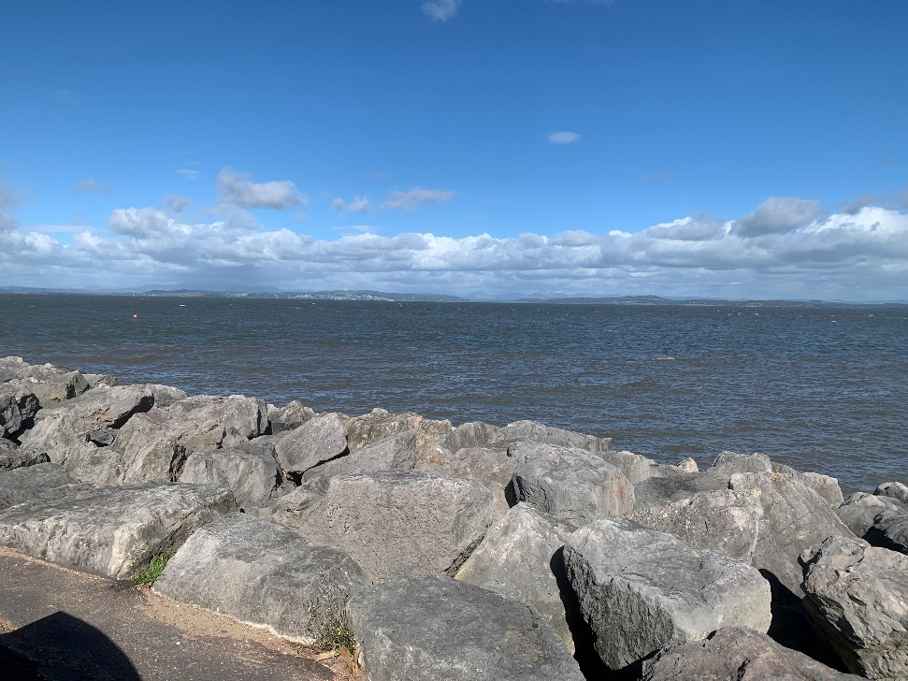
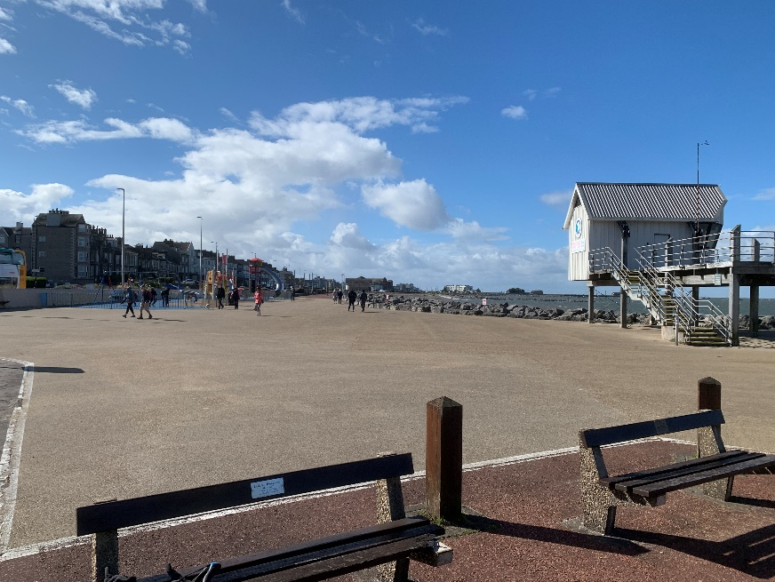
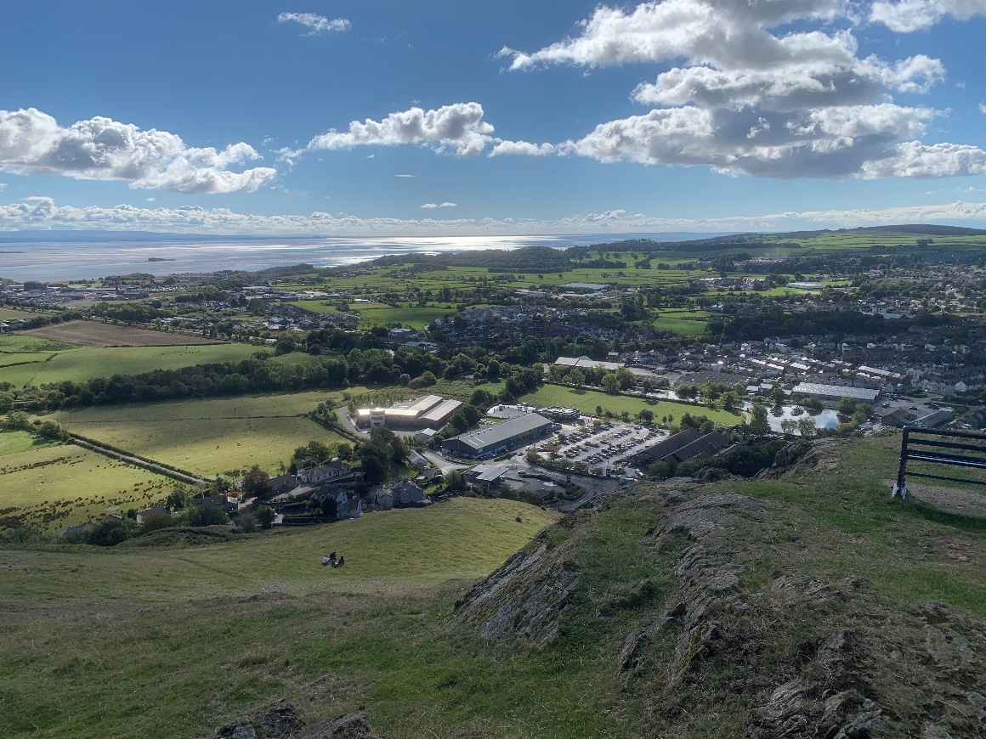
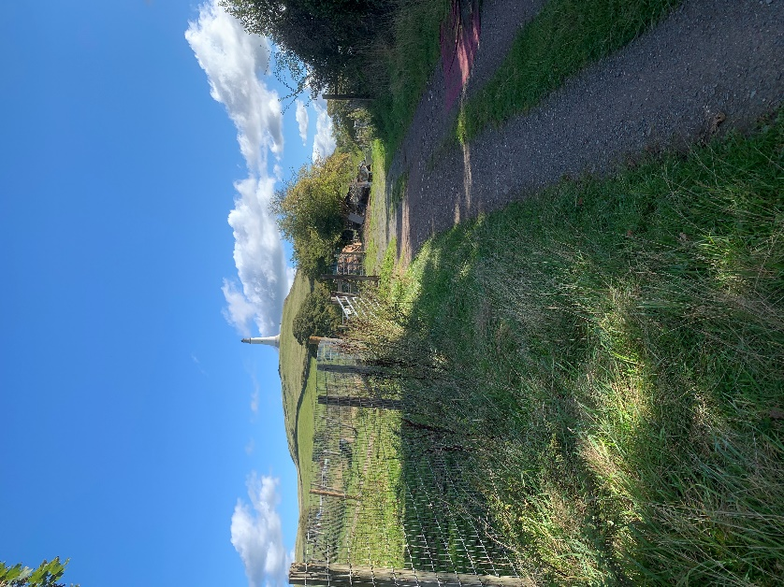
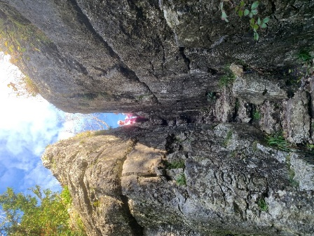
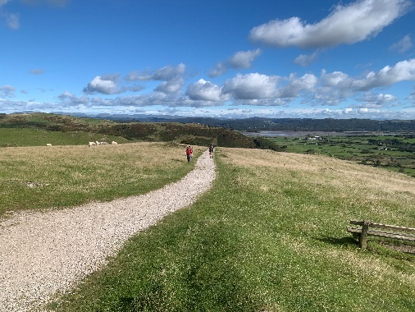
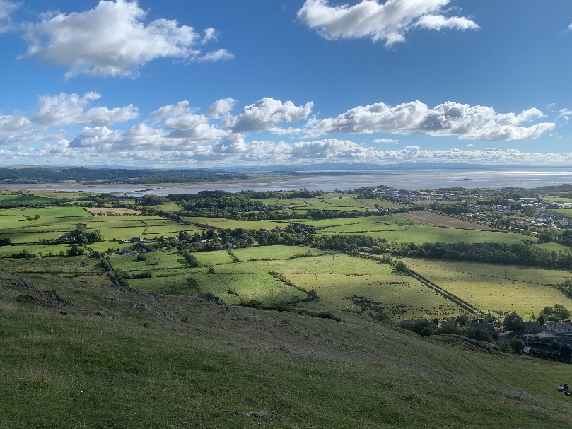
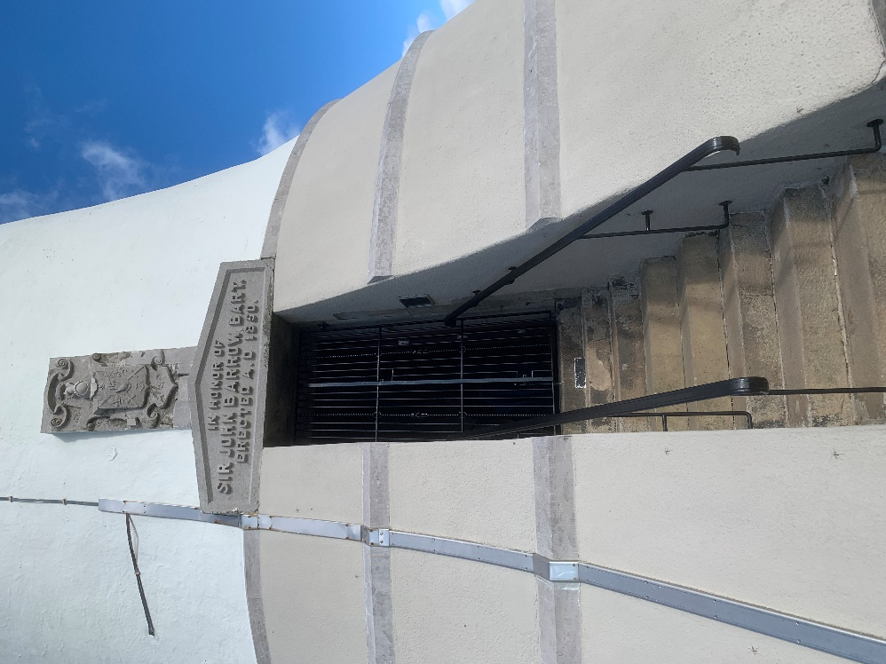
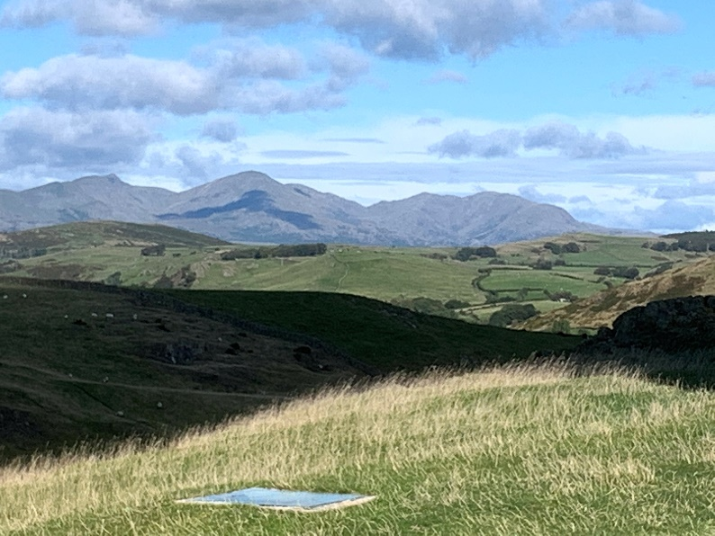
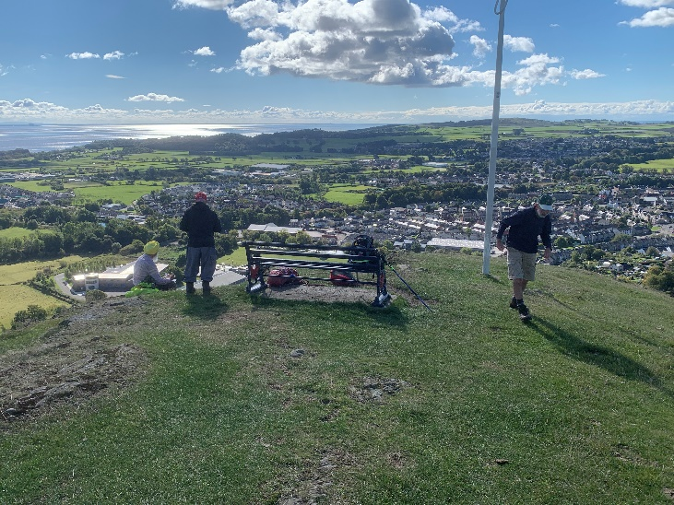
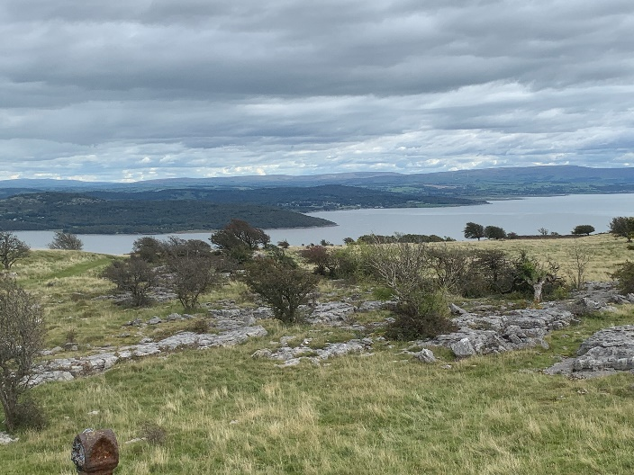

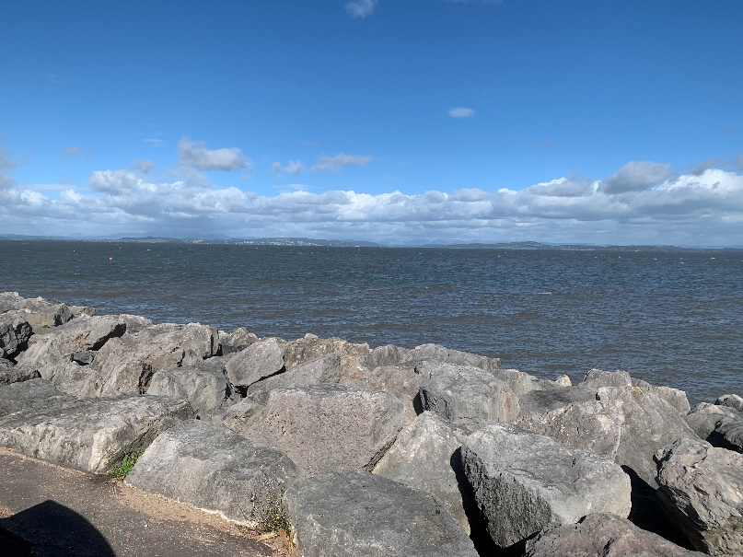
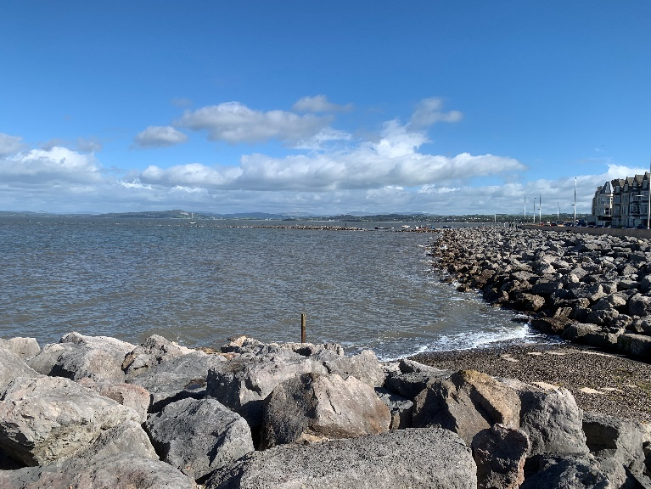
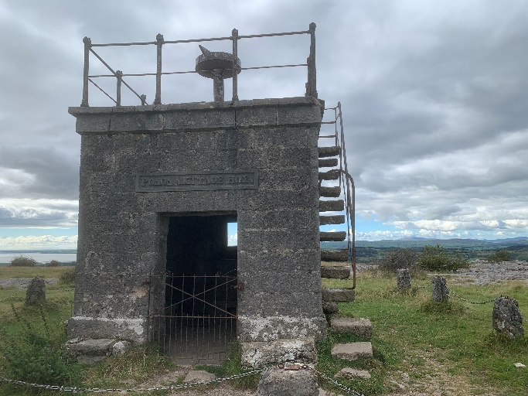
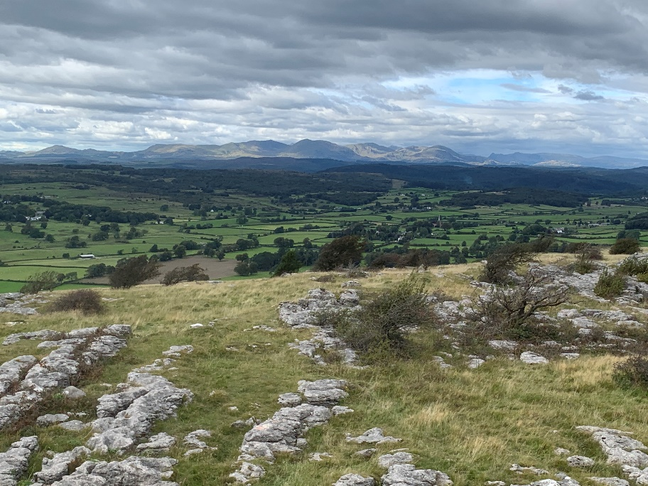
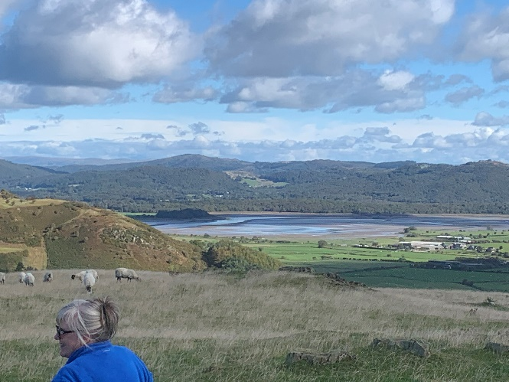
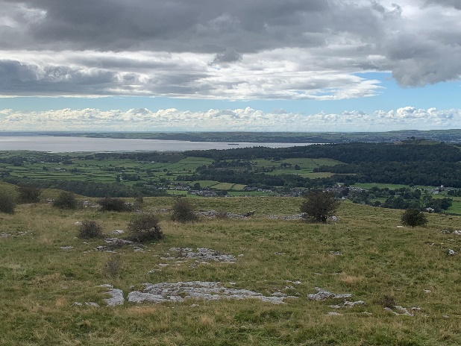
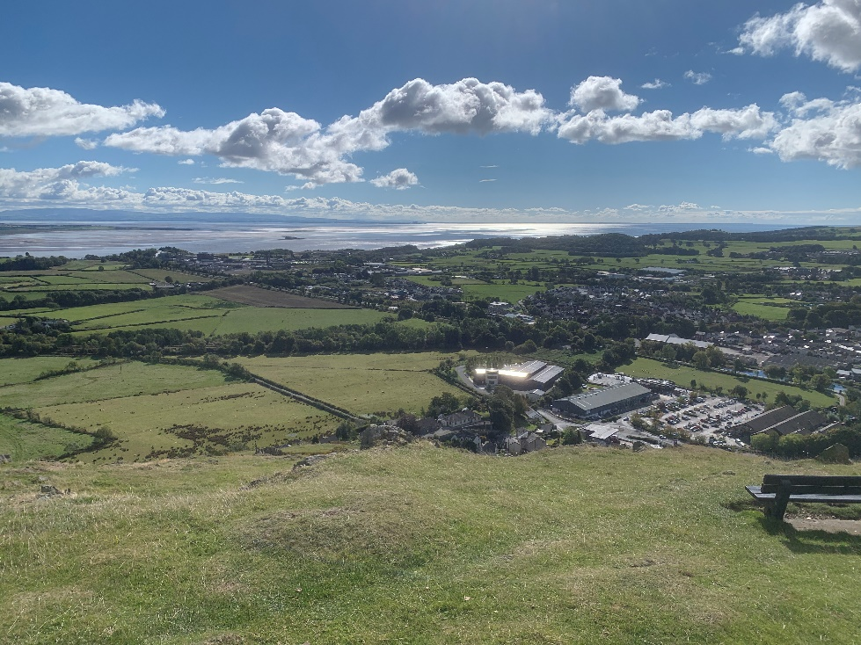
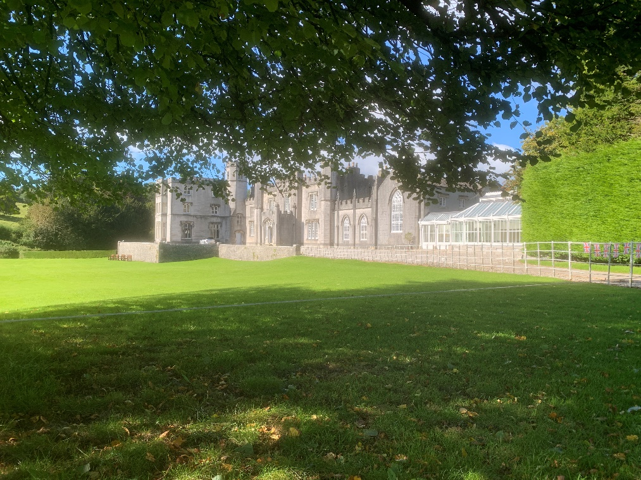
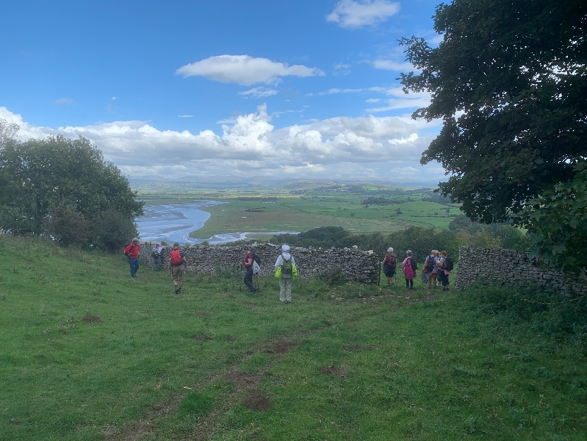
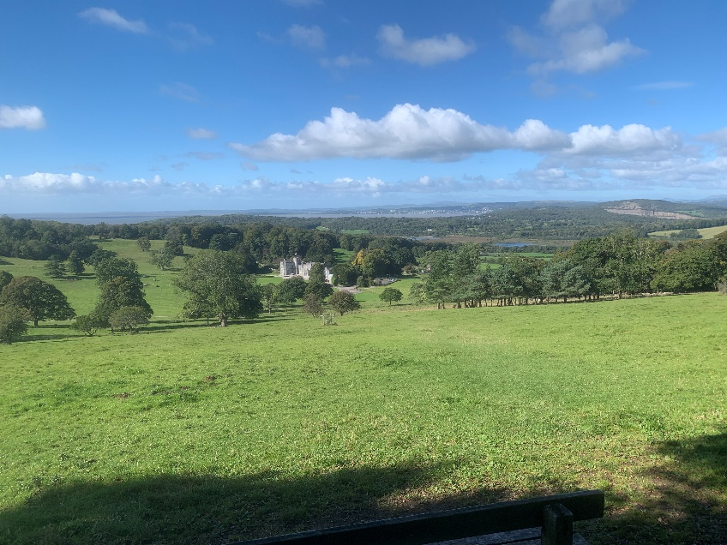
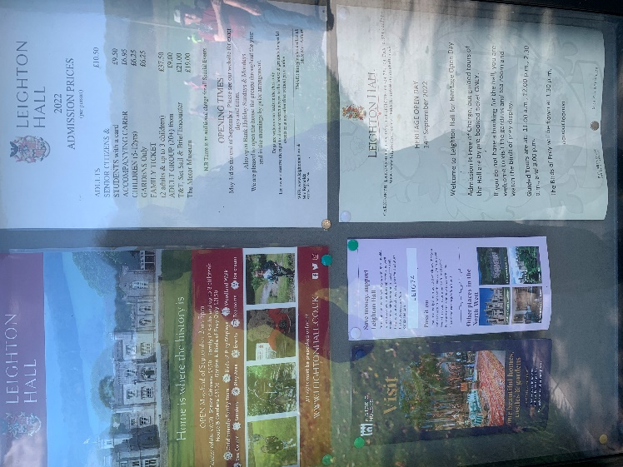
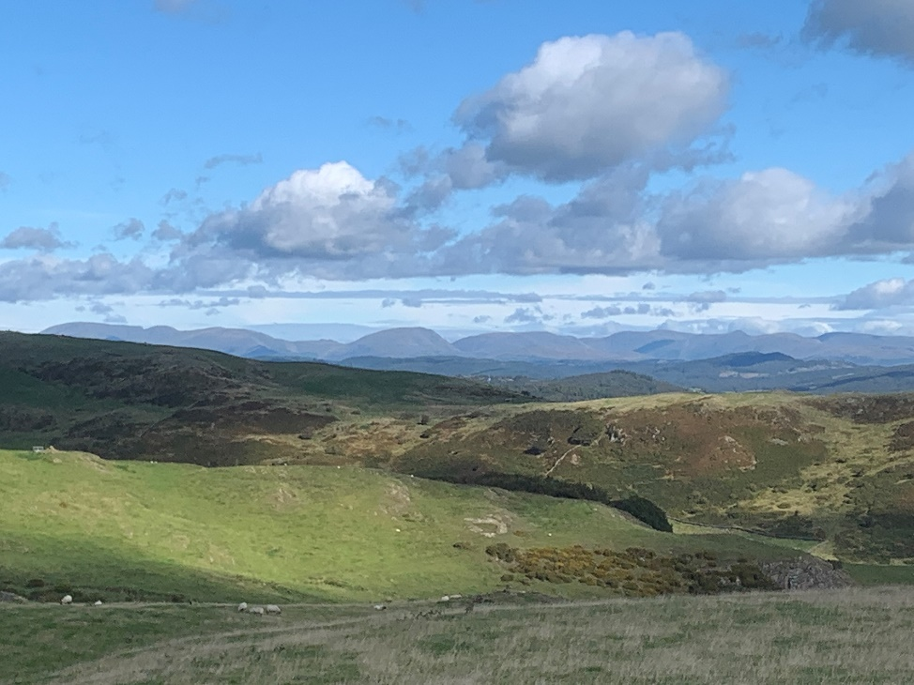

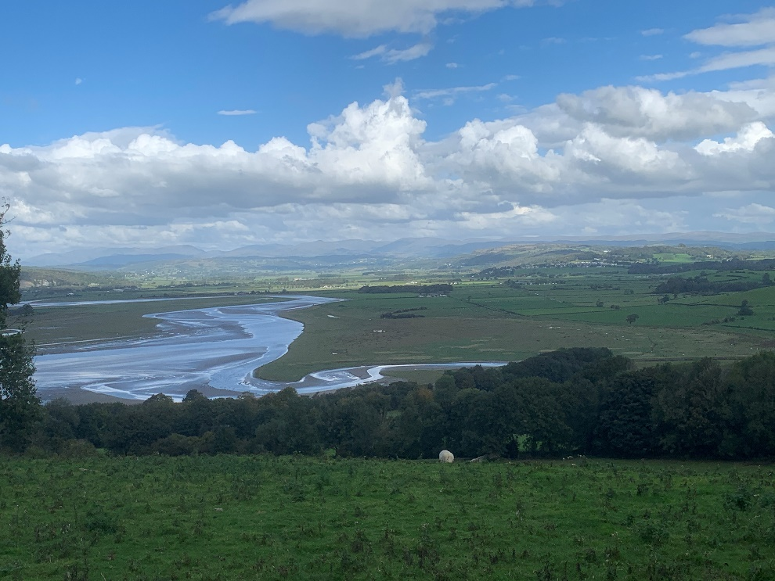
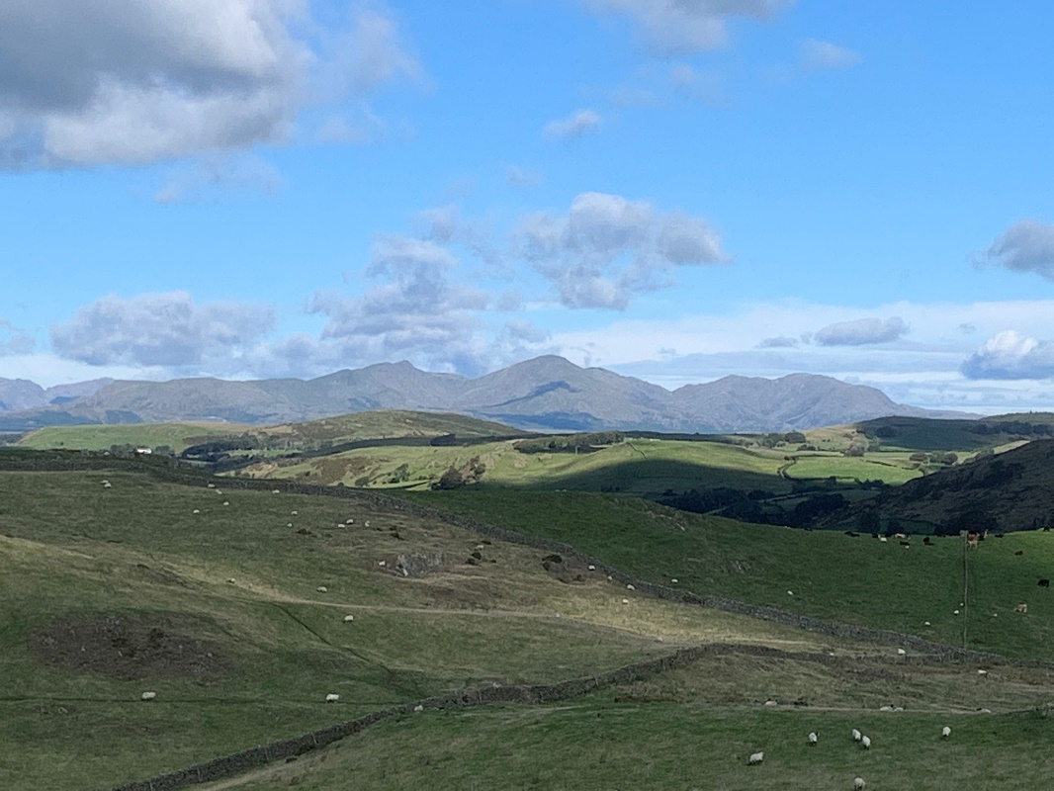

The relaxation in the evenings!!!

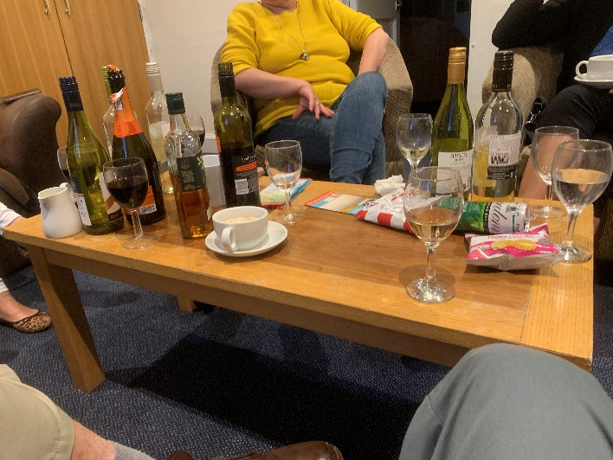

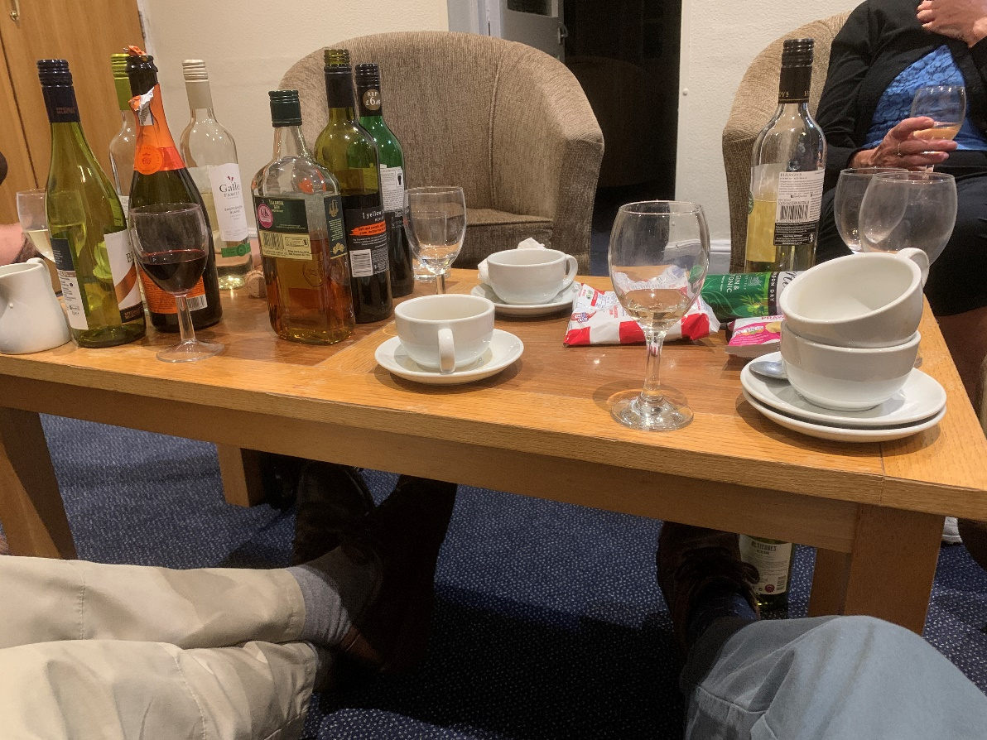

Sample Menu

