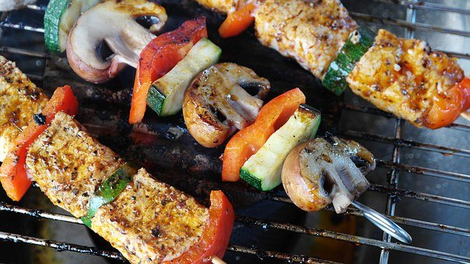

Bradford Senior Wayfarers

Post Covid B.B.Q.

24th June 2021@ 5pm
Airton Farm shop. BD23 4BE
£12 per person
All BSW members are invited
NB. walks to be arranged locally prior to the BBQ.
Please let your walk group leader know if you intending to join us.

