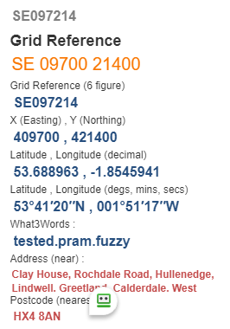
Norland Moor
Start Point:

- Follow track left above boundary wall, to entrance to concrete yard, go uphill to stile in left corner
- Follow track left until fourth row of houses, up steps on right through wall stile
- Bear right, then left at top, follow track to bear right at fork
- Go ahead to follow escarpment edge to Moor Bottom Lane @ SE080221
What3words: curl.guides.plants
- Right, then left path to Clough Moor Bridge @ SE069220
What3words: vines.plan.truck
- Walk across Norland Moor to New Rock Inn @ SE054207
What3words: lamppost.balconies.duration
- After pub car park, turn left on path to cross B6113 Greetland Road
- Go down house drive over stile, then downhill to stile and road, turn left 30 yards
- Turn right at path sign descend to Sandyfoot Clough uphill to Barkisland
- Turn Left onto Stainland Road, downhill to turn left into Barkisland Hall @ SE060199 What3words: bids.city.parent
- Go through metal gates, descend to stile and turn right to follow steam to reach
- Branch Road @ SE066199 What3words jungle.brain.from , turn left until Mill after 500 yards
- Turn right down hill 80yds, then left thro’ mill yard to reach stream
- Follow stream to B 6112 @ SE091662, What3words: relate.refuse.ruler turn left to finish

