Title of Walk: Dean Beck
Distance: Eight Miles - circular - clockwise
Start point:
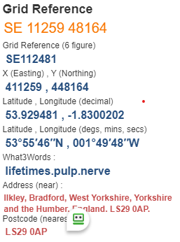
Map Explorer: 297
The what3words locations are taken from Grid Refences provided. Some of the Grid Refences are approximate so subsequently so are the what3words. Always carry an OS map for accurate locations. Should anyone doing this walk wish to provide more accurate what3words combinations the route will be amended accordingly.
- From the Old Stone Bridge take the river path on the left
- Cross the road and turn left uphill to cross the stile into Owler park Woods@SE105488 https://what3words.com/withdrew.afflicted.mashing
- Follow the path thro’ wood to arrive at Low Austerby, straight on to Nessfield @ SE095495 https://what3words.com/ripe.rooms.flippers
- Turn right uphill thro’ gate, continue forward take left path at fork before house
- Continue uphill to pass on to moor past house, bear half right to reach road @ SE106506 https://what3words.com/client.unfilled.however
- Bear right on road for 200 yards then half left to Ling Park plantation @ SE108506 https://what3words.com/yummy.newsreel.dictation
- Go past plantation to cross Park Lane track, ahead thro’ gate towards Hunger Hill Farm @ SE123497 https://what3words.com/shaver.parsnip.nitrogen
- Follow the road downhill turn left over stile passing thro’ old hospital grounds towards Denton @ SE143490 https://what3words.com/exonerate.logged.banter
- Turn right down road then via path to Beck Foot Farm @ SE136487 https://what3words.com/velocity.tidying.suggested pass thro’ farm to cross road and forward to road towards Ilkley, cross swing bridge and take path along river back to start point / finish
