Walk Title: Two Churches
Map: OS Explorer 27. Lower Wharfedale Washburn Valley
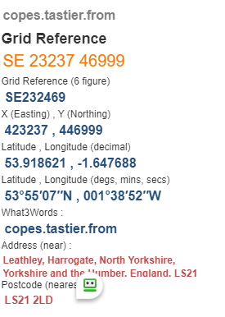
Start point: SE23470
Details: Whah3Words:

The following route shows Grid refences and What3Words to assist in finding your way round. Mistakes may have been made in transposing this information and the refences are no substitute for a group leader using an OS Map for accurate and safe walking.
- Walk on Hall Lane crossing beck @ SE 252472 https://what3words.com/puddings.starring.spotty to enter Riffa Wood.
- Turn Left at the top of wood @ SE256473 https://what3words.com/drainage.pelt.workflow
- Continue forward to Stainburn left up hill to church @ SE248486 https://what3words.com/crystals.couple.clinking
- Walk up Church Lane to Braythorne @ SE245490 https://what3words.com/skis.towel.mistress
- Turn left onto Bridleway, follow to Stile @ SE241490 https://what3words.com/windpipe.thanks.toffee turn left
- Bear half right up hill to West End Farm @ SE238488 https://what3words.com/limits.lecturers.disband
- Pass round the farm to cross the road B6161
- Continue ahead to wall Stile @ SE233490 (steep descent!) https://what3words.com/pimples.wildfires.mimic
- Cross field and follow lane to 200 years beyond Lindley Green, turn left @SE223489
https://what3words.com/bashed.gangs.ideals
- Double back on yourself and turn downhill @ https://what3words.com/choppy.calculate.playful towards Lindley Bridge
- Turn left @ SE225482 https://what3words.com/parked.compacts.widest and follow beck to Lindley Mill
- Turn right at road B6161 to return to start point Leathley Church
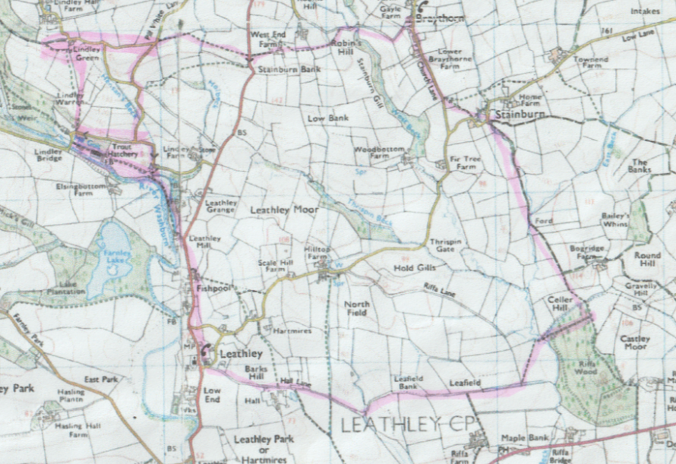

Approximately 6 miles but can be extended to 8 using route Walk Title: 2 Churches plus

