Title Lotherton and Garforth

- Eight Linear OR Nineish Circular
- Start Point East Garforth Rail ST.
- Grid Reference SE 415330 https://what3words.com/used.front.hypocrite
- Map Explorer: 289 Leeds / Harrogate

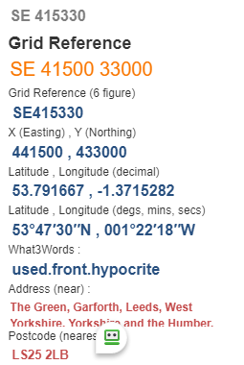

- Exit station follow path thro' houses passing Medical Practice, left then right to end if road; turn left to post office @ SE413336
- Cross road to go thro' industrial site, to reach “Fly Lane” path pass wood on your left and go under new motorway (tunnel) go past Lily Pit Cottage and enter Parlington Woods @ SE415350
- Thro' trees to reach Parlington Lane pass cottage on your right and go thro’ tunnel. Look for stile on your left to enter Aberford Park, turn right on reaching tree lined road; exit onto Aberford Road turn right for 200 yds then right again to enter church grounds @ SE433372
- Leave church via front gate and follow track thro' houses and school, eventually reaching the Great North Road, turn right then left onto Lotherton Lane passing under bridge of A1 (M) turn left and follow Stocking Lane, turn right reaching "The Rein" F/P @ SE446371
- Turn right on the B1217 (busy) and turn left to enter Lotherton Hall Estate on your right @ SE410363, pass bird aviary and refreshment area, good lunch spots and exit the grounds on F/P Ranger Walk towards Micklefield. Go thro' wood and follow track at wood edge to turn right near Hartley Wood Cottages @ SE449336
- Go over Motorway, pass farm area and turn left on road, turn right and pass school and STOP on reaching F&P......You can A turn left to reach road and turn right to reach Micklefield Rail Station near bridge OR ....... B take path straight ahead - this leads to the A656, turn left for 200 yds then follow F/P on your right BEFORE the bridge, this keeps alongside the rail track to the FINISH.

