Joining Meetup

Joining Meet up for individuals is free but costs BSW to have membership.

Best to just join Mid-week wayfarers unless you want contacting by other groups.

You don’t have to make you ‘profile’ visible to anyone if you don’t want to. It may require a photo when you are signing up for the first time, but it doesn’t have to be of you. (It can be your cat or a country view!)
- Enter "www.meetup.com" in the address bar of your web browser of choice. e.g., Google Chrome, but you can choose your favourite browser.
- Click the red Sign-Up button. By clicking Sign Up, you will be taken to the sign-up page, where you can enter your information.
- Choose to sign up through Facebook, Google, or email. Click Continue with Facebook to sign up for Meetup with your Facebook account, or click Continue with Google to sign ...
- Enter the information required for your chosen method of registration. ...
- Verify your email address. Meetup will immediately send an email to the email address you used to sign up. ...
- Click " Log In " to sign into Meetup for the first time. ...

For more detailed instructions:

https://techboomers.com/t/how-to-sign-up-for-meetup#:~:text=1%20Enter%20%22www.meetup.com%22%20in%20the%20address%20bar%20of,in%20to%20Meetup%20for%20the%20first%20time.%20

Our page on Meetup contains everything that is on our website, but people only look at the first screen and don’t click ‘Read More’.

Whereas I can dictate how the Website Looks and what you see, Meetup limits my ability to format it, so we have to accept its layout.

You can short circuit the process to find Midweek Wayfarers by going here:
https://www.meetup.com/wayfarers-mid-week-walking-group/

Initially all you see is this:
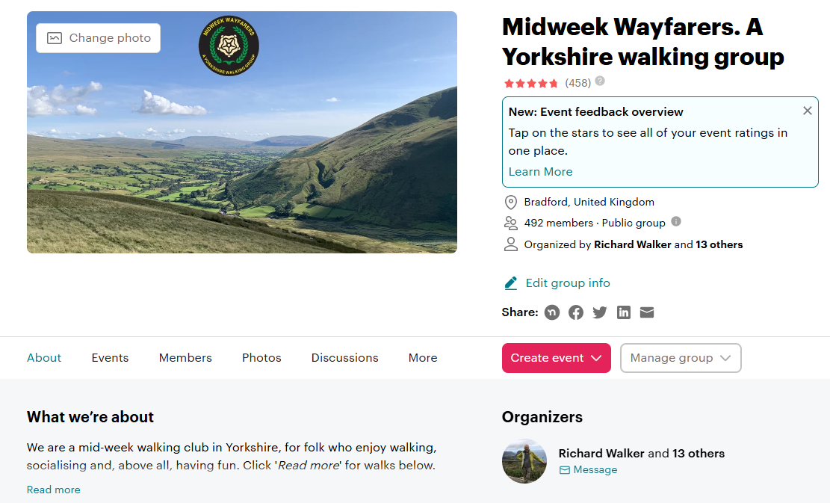

Once you click on ‘Read More’ you open the following:

- All the content from our MWW website which is on Meetup.
- Links to all our walks.
- Access to Google Sheets for those who want to enter walks.
- Links to all the reference items that may be relevant.
- Links to our full schedule of walks.
- We can publish events and keep a record of who attends.
- Members can RSVP / Attend / Submit and cancel attendance.
See below:
