£1 per person using this copy
Bradford Senior Wayfarers
Founded in 1979 by Tom and ruby Wilcox
April to July 2020
Hon President .. Irene Jowett
Acting Chair .. Verner Wheelock
Acting Secretary .. Pat Meadows
Acting Webmaster .. Richard Walker
Treasurer ... David Webster

Comments from Verner Wheelock Acting Chair:
On behalf of all members of the club I would like to express our gratitude to Roger Pollard as he retires from his post. He has given many years of dedicated service to the Bradford Senior Wayfarers. If had not been for Rogers’s commitment and dedication, I think it is fair to say that the club would have faded away, but now we are in a stronger position with new executive committee in place to take us forward.

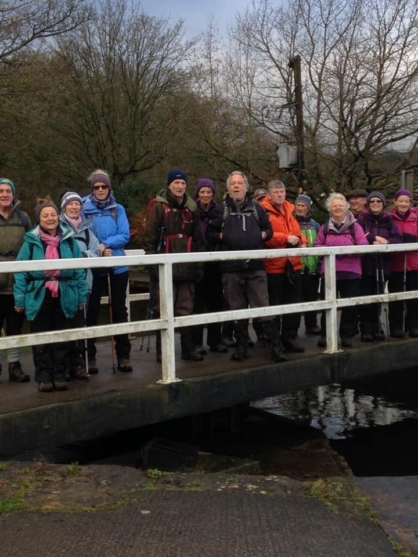
Photo .. Thursday eight milers
Whilst every care is taken on the walks please remember everyone taking part does so at their own risk. Please ensure that you wear appropriate footwear and clothing.
All members are expected to contribute to the development of the group by leading or for those less experienced in supporting walk leaders or group leaders with the administration and organisation of their group
Dogs are not allowed on B.S.W. walks.
NB All information regarding walks is correct at the time of printing, please check the website or with group leaders for updates / alterations. https://www.seniorwayfarers.org.uk/index.html

Closing date for group leaders to compete their next syllabus to Pat: 2nd July 2020

