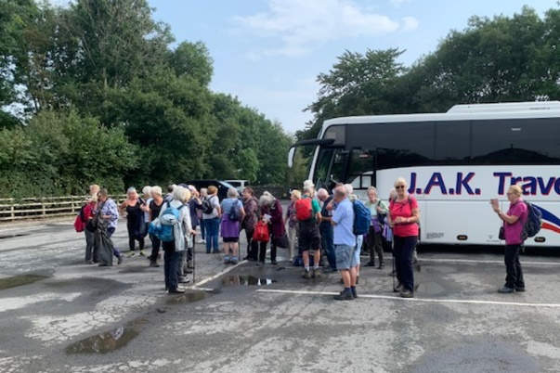
Thanks to Verner and Pat for organising a great day out in Hawes. A special thanks to John for getting such a high level of support for the event. The various groups started walking around 11.15 and seemed to cross paths on various occasions throughout the day.

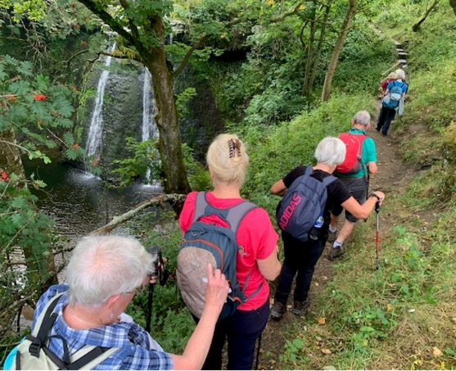
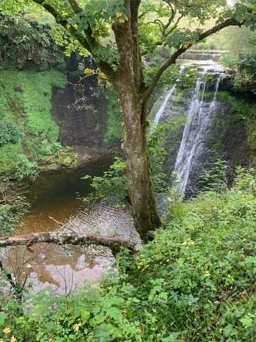
Someone must have had influence with weather Gods as it was warm and sunny, if a tad hazy, and miles better than any of the weather forecasts.

Sitting in the sunshine outside the Fountain Inn at 4.00 with pint of shandy was great way to end a walk. (Not to mention the ice creams half an hour earlier!)
