There is no substitute for a map and compass but for backup:
You can use what3words Offline - no telephone signal or data (its GPS)
https://www.youtube.com/watch?v=_JBwRxjCq-k&list=PLjaROP0Mmk_H6LWnNCdKjby0LbtxFFvLL&index=11
- Make sure you have the what3ords app
- Even if totally offline what3words will work
- Open the App on your phone and click on the locate button. Like this
- It will immediately show your what3words location
- The Map may not load but that’s OK - the 3-word address comes up
- The location comes from a satellite so long as you are not in a cave and the phone can see the sky it will work. Even in a desert or a forest anywhere in the world.
- You can pass this on in an emergency situation. You can also navigate to a 3-word address even if offline. The map won’t load but it will bring up the compass mode and distance.
- If you want ‘turn by turn’ navigation, even if offline, you can use something like Navmii.
- Type the 3-word address onto Navmii and it will have offline maps, and you can do the entire journey offline without a data signal.
- Also, you can use Google Maps, Apple Maps, Waze
Using what3words from the Midweek Wayfarer’s web site or Meetup
- Make sure you have the what3words app
- On the left-hand column description in blue click on the link and it will open the location in what3words
- At the bottom of the page in the middle click on Navigate
- It will open the various navigation options you have on your phone like: Google Maps, Apple Maps, Waze, Namii.
- Choose the one you want, click start, and you will be directed to within 15 meters of the location you want anywhere in the world.

Why do I need what3words when I have Google Maps?
https://www.youtube.com/watch?v=UvyaycpLOmk&list=PLjaROP0Mmk_H6LWnNCdKjby0LbtxFFvLL&index=10
- Google maps isn’t accurate enough (Apple Maps, Navmii, Waze)
- Its not case of either or. You need to use them together.
Share your what3words address with someone else
- Open the app and click on your location
- Click on Share at the bottom left
- Open say: What’s app and paste the address in, add your comment and send it
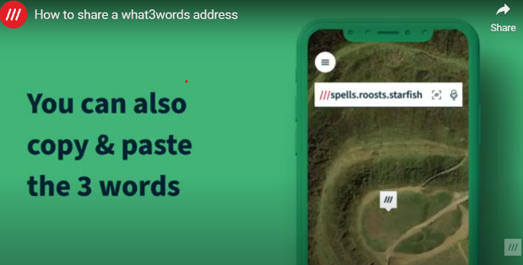
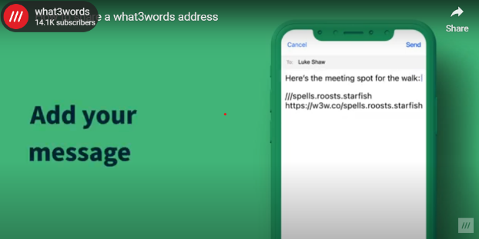

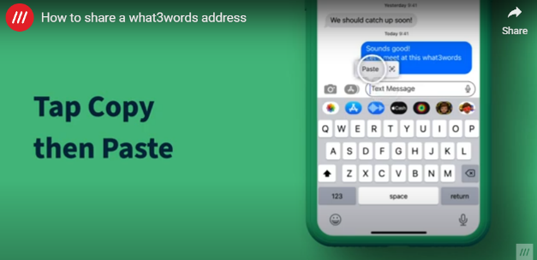
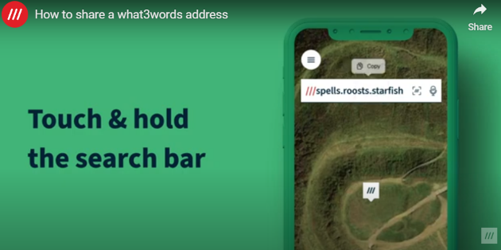

Save a what3words address
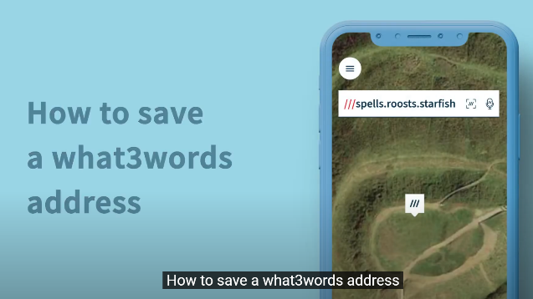
- Save a What3Words address for future refence
